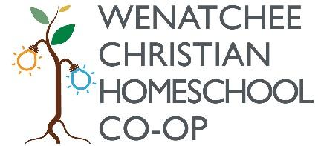

Scholarship Application Form

Dear Family,

Wenatchee Christian Homeschool Co-Op is community orientated co-op geared towards enabling families to gather in a setting that is both educational and enriching. We make every effort to ensure families who need financial assistance receive it. There is a budgeted amount of funds for each session available for families at the discretion of the Board. These funds will cover as much as is budgeted per family, any extra class fees will still apply. All families who apply for financial aid agree to make every effort to attend for the session your family receives financial aid. Barring illness or serious injury, you must be on-time and prepared for class each Wednesday. All recipients must also read and acknowledge understanding of the WCHC Handbook. Any information collected for the purposes of financial aid is confidential. By filling out and turning in this form you agree to the above requirements.

